FRIENDS AND FAMILY TEST
Results for April 2024

Thank you to all the patients who completed a friends and family test survey in April 2024.

- How likely are you to recommend our practice to family and friends if they needed similar care or treatment?
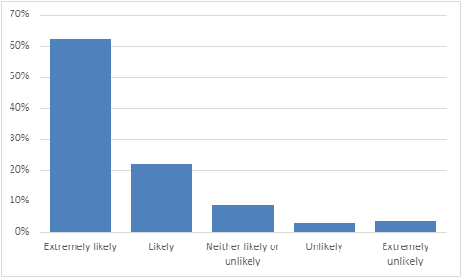
62% are extremely likely to recommend the practice.
22% are likely to recommend the practice.
9% are neither likely nor unlikely to recommend the practice.
3% are unlikely to recommend the practice.
4% are extremely unlikely to recommend the practice.

- If we could change one thing about your care or treatment, what would it be?
- Dr Brown is always amazing. First class service again from Dr Brown.
- Dr Hart and Dr Harris are fantastic but can’t get to see them very often.
- I was seen by Dr Craghill on time and I thought he was excellent.
- Dr Harris is the best. Carol was funny and a star. Carol was amazing.
- Justine and Dr Hart are brilliant. Fantastic surgery. Wonderful staff.
- I attended to see Dr Hart. I can honestly say she is a fantastic doctor.
- Dr Challa was excellent during our call.
- Tracey was really welcoming and helpful, put me at ease.
- Tracey was very reassuring and professional. The nurses are lovely.
- Very satisfied with all elements of my treatment. You can’t improve on excellent.
- Care was excellent. Treated with great respect from front desk and doctor.
- Staff are all helpful and respectful. Reception staff all really lovely and helpful.
- Doctors’ receptionists usually get bad press. The ones at Coppull are very friendly and kind.
- All staff from doctors to cleaning staff are always very friendly and courteous.
- I felt really listened to with my concerns and a plan with next steps was put in place.
- One thing that has really stood out to us is your excellent customer service.
- The triage system works well. After using the new triage system, I was pleasantly surprised.
- More face to face appointments. Be able to get appointments sooner.
- Not sure the new booking system is for everyone. Take away the complicated triage service.
- Do not like the new system. Less technology and more human contact.
- Having to wait three weeks to see a doctor is not acceptable.
- Be able to go back to ringing for an appointment. Phone calls answered quicker.
- Waiting at reception in the queue is not confidential for customers.

